
Mrs. Henderson’s
Discipline Plan
Agricultural Education Department

PROTOCOL
- Follow directions the first time they are given.
- Follow Cross Creek High School’s R² : Respectful and Responsible PBIS Rubric
- Be in your seat, ready to work, when the bell rings.
- Follow all school rules and the code of conduct handbook.

IF YOU CHOOSE TO BREAK A RULE:

1st Offense: Warning
2nd Offense: Notify Parent(s)/Legal Guardian(s)
3rd Offense: Notify Parent(s)/Legal Guardian(s)
Teacher Detention-1 hour after school
4th Offense: Submit a “minor” in Infinite Campus Spotlight

SEVERE DISRUPTION
AUTOMATIC REFERRAL TO THE CORRESPONDING ASSISTANT PRINCIPLE

~~~~~~~~~~~~~~~~~~~~~~~~~~~~~~~~~~~~~~~~~~~~~~~~~~~~~~~~~~~~~~~~~~~~~~~~~~~~~~~~~~~~~~~~~~~~~~~~~~~~~~~~~~~

STUDENT
I have read this above plan and understand it. I will honor it while in class.

STUDENT NAME (PLEASE PRINT) ___________________________________________

STUDENT SIGNATURE________________________________ DATE__________

PARENT/LEGAL GUARDIAN
My child has discussed this plan with me; I understand and support it.

PARENT SIGNATURE_____________________________DATE__________

TEACHER
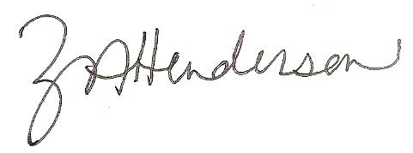
I will be fair and consistent when administering the above plan.

TEACHER’S SIGNATURE__________________________ DATE 8/6/2024___

Notice of Non-Discrimination
The RCSS does not discriminate on the basis of race, color, religion, national origin, sex, age or disability in its program and activities and provides equal access to the Boy Scouts and other designated youth groups.

